Learning by Experience
https://involvedliving.osu.edu/mundo

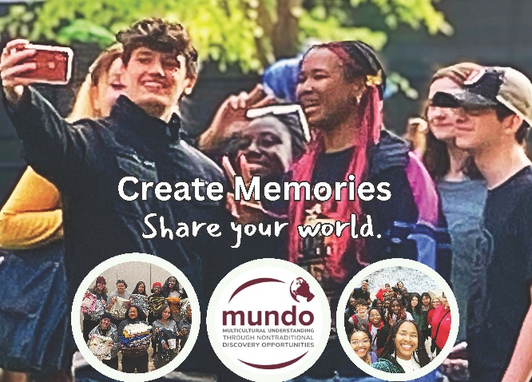

MUNDO is a residential learning initiative and student organization designed to expose Ohio State students to intentional community service and learning opportunities that enable them to engage in and promote open-mindedness, multicultural understanding, and leadership toward social change.

This organization and its members shall not discriminate against any individual(s) for reasons of age, ancestry, color, disability, gender identity or expression, genetic information, national origin, race, religion, sex, sexual orientation, or protected veteran status.

MUNDO Executive Officer Positions 2024-2025 (ODNUM)
President
- Serves as official student spokesperson for MUNDO.
- Represents the MUNDO General Body on any committee or task force pertinent to the mission of MUNDO.
- Works with the MUNDO Coordinator, Staff/Faculty Mentors, and the other MUNDO Executive officers to create and co-facilitate weekly MUNDO meetings.
- Coordinates room reservations, speakers, food arrangements, and other essential logistics for weekly MUNDO Meetings and (at least monthly) ODNUM meetings.
- Provides ACTION TEAM leaders with organizational updates and resources as needed to support ACTION TEAM planning efforts.
- Serves as a liaison to partner Involved Living Organizations and the College of Arts & Sciences PASS program at appropriate meetings, gatherings, and events for social and collaboration purposes.
- Updates Student Life and/or MUNDO programming database after MUNDO events.
- Coordinates and plans regular student executive officer meetings.
- Seeks out and facilitates collaboration with other organizations on-campus and in the Columbus community.
- Initiates the formation of new committees as deemed necessary by ODNUM and oversees the selection of committee chairs.

Vice President
- Supports and aids in all MUNDO communications including social media, marketing, and electronic communications to ODNUM and the General Body.
- Assists the President with liaison responsibilities as needed.
- Tracks and awards MUNDO participation points and facilitates MUNDO Induction Ceremonies
- Manages and updates the MUNDO listserv.
- Creates and distributes weekly MUNDO e-newsletters.
- Provides regular updates from and to partner Involved Living organizations and initiatives within University Housing (within the Office of Student Life).
- Provides ACTION TEAM leaders with organizational updates and resources as needed to support ACTION TEAM planning efforts.

Treasurer
- Serves as a liaison to partner Involved Living organizations and the College of Arts & Sciences PASS program at appropriate meetings, gatherings, and events for funding-related purposes.
- Identifies and facilitates major MUNDO fundraising efforts and grant opportunities.
- Works with ACTION TEAMS to monitor and meet the budgetary goals and expectations established for NDOs or other MUNDO-related events or activities.
- Provides ACTION TEAM leaders with organizational updates and resources as needed to support ACTION TEAM planning efforts.
- Works with MUNDO Coordinator and Advisors to maintain overall budget.

ACTION TEAM Leaders
- Serve as acting coordinators and lead planners of an ACTION TEAM as determined by ODNUM.
- Coordinate educational or co-sponsored programs or events that support the intended learning outcomes of the MUNDO, including an educational travel experience and weekly general body meetings.
- Monitor and meet the budgetary goals and expectations established for the program or event they are charged with coordinating.
- Provide regular updates on the progress of ACTION TEAMS during weekly General Body meetings.
- Meet at least monthly with the MUNDO Staff/Faculty Mentors to discuss the progress of MUNDO projects and events.
- Oversee their respective ACTION TEAM, a group of general body and ODNUM members who are self-selected and confirmed at the beginning of each semester.
- Coordinate, plan (including agenda preparation, location selection, and scheduling), and attend weekly or biweekly ACTION TEAM meetings.
- Meet with other ACTION TEAM Leaders to coordinate and divide responsibilities for planning different aspects of larger-scale MUNDO experiences.

MOCA Coordinator
- Works with the MUNDO Coordinator to facilitate, or co-facilitate, MUNDO 2 GO learning opportunities provided to University Housing-owned properties on-campus and in the Columbus community.
- Works with MUNDO ACTION TEAM Leaders to create and implement ice breakers, reflection activities, and discussion topics to supplement on-campus and off-campus NDOs.
- Works within ODNUM to create, facilitate, and assess two MUNDO retreats (one per semester) for General Body Members and ACTION TEAMS focused on issues related to community engagement (service), cross-cultural learning, and social change (leadership).
- Oversees MOCAs by coordinating orientation and monthly meetings, as well as passing along important information and resources to be distributed in the residence halls.

Service Coordinator
- Works under the direction of the Student Coordinator for Administration and Collaboration to design, plan and engage in service activities.
- Works towards and creates long-term service projects with other organizations around the community.
- Plans a minimum of one service project per month.
- Works with ACTION TEAM leaders to intentionally incorporate service into MUNDO meetings, gatherings, and NDOs.
- Identifies campus service opportunities to go out in internal and external communications.
- Coordinates an increased number of virtual and in-person service opportunities in collaboration with the Pay it Forward office, other ILO groups, and local community partners.

Internal Communications Coordinator
- Documents and curates photo archive of MUNDO activities, manages Microsoft Teams materials, organizational minutes, and GroupMe updates)
- Works in collaboration with the MUNDO Coordinator and staff/faculty mentors

External Communications Coordinator
- Creates marketing materials, manages the MUNDO website, calendar, Instagram, swag/merchandise, Facebook, a public educational archive of MUNDO resources, and large-scale campus marketing.
- Works in collaboration with the MUNDO Coordinator and staff/faculty mentors

Important information about the MUNDO Election/Selection Process 2024-2025

- The President, Vice President, and Treasurer (collectively referred to as Student Executive Officers) must have served on ODNUM or have become an active member of MUNDO during the year before applying to be a MUNDO student executive officer.

- The role of the MOCA Coordinator can only be filled by a student living in an Ohio State Residence Hall or property.

- Students residing in Ohio State residence halls or campus properties are strongly encouraged to apply for all MUNDO Student Leadership roles including Student Executive Officers, ACTION TEAM Leaders, and the MOCA Coordinator.

