**Involved Living Organization**

**Info Packet 2021-2022**

**RHAC –** Residence Halls Advisory Council

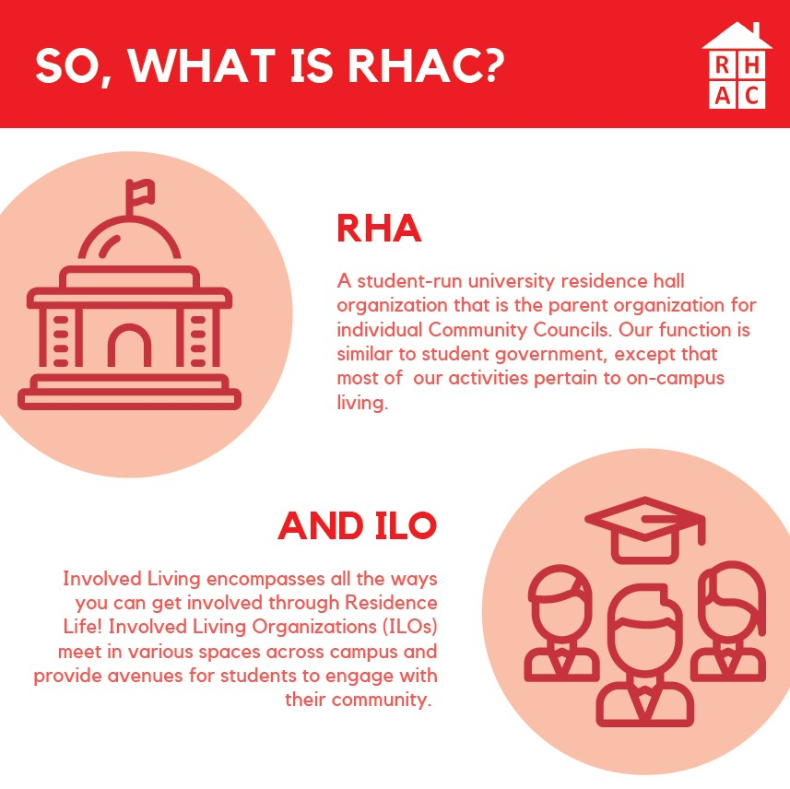

The Residence Halls Advisory Council (RHAC) strives to create a premier residence hall experience and serves as the representative body for all on-campus students. Each Community Council sends at least one executive board or general body member per hall to attend RHAC meetings and serve as the RHAC Senator for that hall. Students work within the Senate where they join committees, create programs, approve funding and voice their opinions and concerns for the betterment of the student residential experience. Come to our meetings every Tuesday at 7pm and have your voice heard!

**What is RHAC?**

A student-run university residence hall organization that is the parent organization for individual Community Councils. Our function is similar to student government, except that most of our activities pertain to on-campus living.

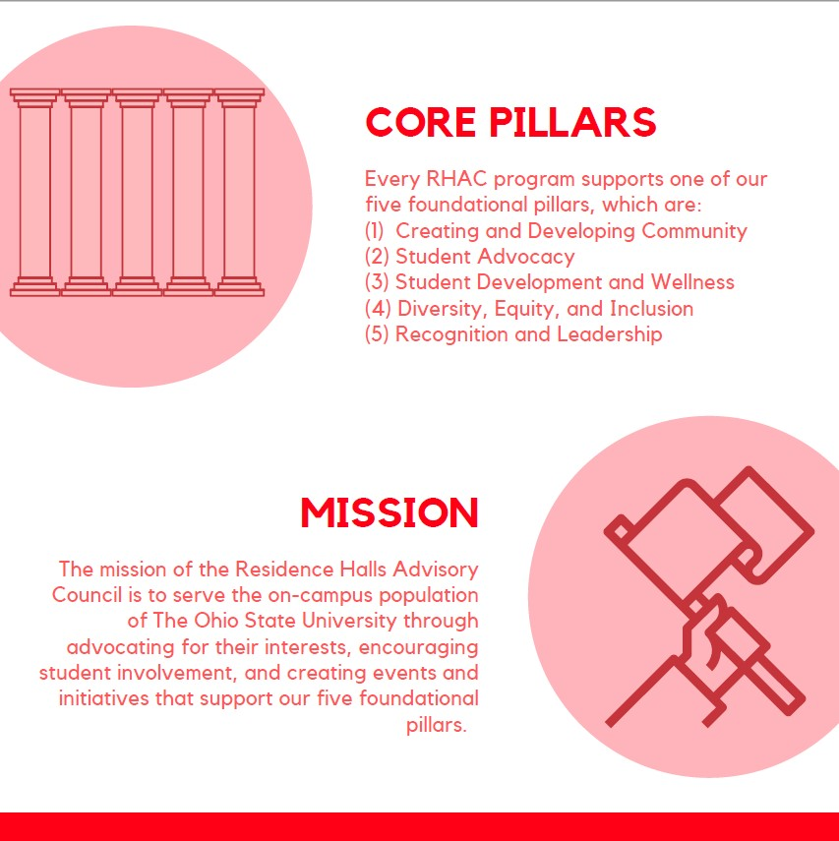

**What is an ILO?**

Involved Living encompasses all the ways you can get involved through Residence Life! Involved Living Organizations (ILOs) meet in various spaces across campus and provide avenues for students to engage with their community.

**Core Pillars**

Every RHAC program supports one of our five foundational pillars, which are: Creating and Developing Community, Student Advocacy, Student Development and Wellness, Diversity, Equity, and Inclusion, and Recognition and Leadership

**Mission**

To serve the on-campus population of The Ohio State University through advocating for their interests, encouraging student involvement, and creating events and initiatives that support our core pillars.

**Who is RHAC?**

**Members**

Every student who lives on campus is a member of RHAC. All of these students can take part in any of our events and programs, and anyone who lives on-campus is welcome to attend our weekly RHAC meetings during the academic year.

**Senators**

Every residence hall or hall complex selects one or two individuals to attend RHAC meetings as representatives of their residence hall Community Councils. Senators constitute most of the RHAC’s voting members.

**Executive Board**

The Executive Board has 7 members who are elected by the Senate in the Spring; a President and Directors of Operations, Programming, Finance, Outreach and Marketing, Student Advocacy, and a National Communications Coordinator

**Advisors**

Our advisors are full time Residence Life professionals who work with the Executive Board to develop new initiatives that will encourage the sustained growth of a diverse community on our campus.

**What are RHAC’s Services?**

**Outreach**

From student organizations to paraprofessionals in Housing Dining, Sustainability, and Security, RHAC serves as liaison between on-campus students and the university. Student development and wellness, as well as diversity, equity, and inclusion, play key roles in our outreach efforts.

**Advocacy**

This is one of RHAC’s 5 core pillars, and we take action to represent all students on campus. Our advocacy committee works to develop and share a better understanding of social justice on campus, and strives to engage with the diverse student population.

**Collaboration**

RHAC is always open to collaborating with other student organizations on campus, providing volunteers and assistance with planning, marketing, and funding projects and events. All collaborations are centered around one or more of our 5 core pillars to support the on-campus population.

**Programming**

RHAC hosts on and off campus events for the benefit of the student body. All events are free and open to collaboration. We encourage students to get involved and participate in events, which often feature fun and interesting activities as well as opportunities to receive RHAC merchandise or other prizes.

**Grants & Scholarship**

RHAC grants offer funds to Community Council and Residence Hall personnel for programs, hall improvements, or other residence hall initiatives that will enhance the student experience at The Ohio State University. We also award scholarships to students who have made substantial contributions to the residence hall community.

**Leadership Positions**

RHAC is a great fit for any ambitious students with an interest in advocacy, marketing, or programming, and generally, for students passionate about building a strong community across campus. RHAC members may further their leadership potential through joining one or more of our committees, and may also run in elections for a position on the Executive Board.

**How Can YOU Get Involved?**

**Students**

* Attend a meeting.

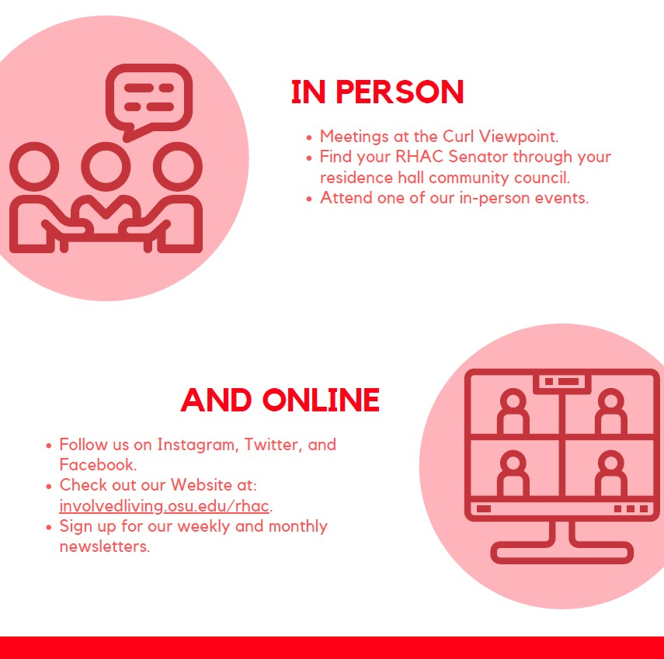

* Participate in a RHAC event.
* Run for Community Council and represent your neighbors as a RHAC Senator.
* Join one of our committees and help RHAC with programming, finance, outreach, recognition, or advocacy.
* Apply for the RHAC Scholarship.

**Organizations**

* Become a RHAC partner.
* Collaborate on marketing and outreach initiatives in the residence halls.
* Connect with our vast body of members and Senators.

**In Person**

* Meetings at the Curl Viewpoint
* Find your RHAC Senator through your residence hall Community Council
* Attend one of our in-person events

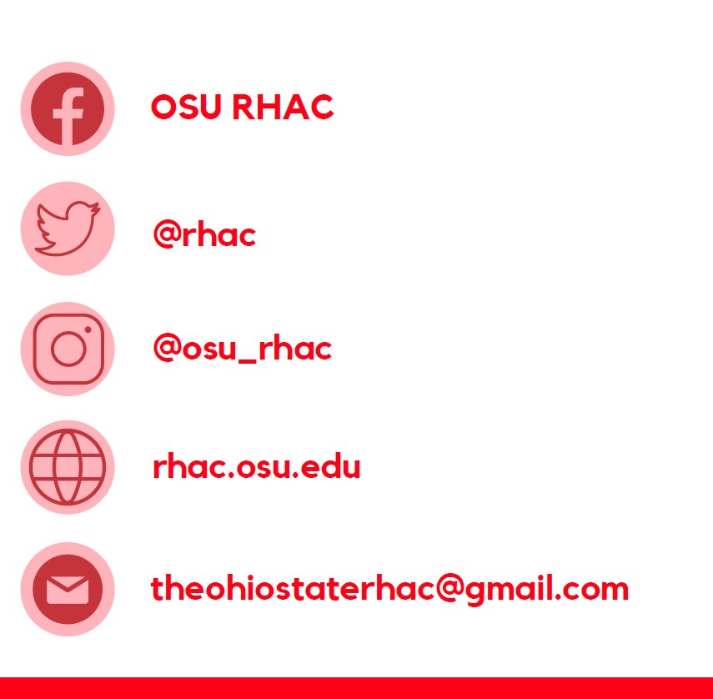

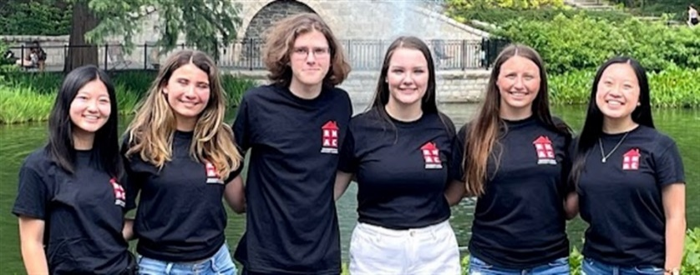

**Online**

Follow us on Instagram, Twitter, and Facebook

Instagram: @osu_rhac

Twitter: @rhac

Facebook: OSU RHAC

Website: <http://involvedliving.osu.edu/rhac/>

Sign up for our weekly and monthly newsletters.

Email: [ohiostaterhac@gmail.com](mailto:ohiostaterhac@gmail.com)

**BSA –** Black Student Association

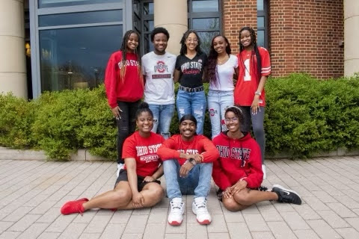

The Black Student Association (BSA) is a premier organization that seeks to promote Black excellence, inspire leadership, advocate for justice, offer aid to those in need, and strengthen the bond between Black students in the community (formerly known as bOSU). The best way to get involved with BSA is to attend weekly programs and other special events. Information is accessible to find out more at the involved living website or on our social media.

1. [**http://involvedliving.osu.edu/bsa/**](http://involvedliving.osu.edu/bsa/)

**BSA Provides**…

The Black Student Association provides a safe space to cultivate joy, holistic wellness, and community. BSA provides ample opportunities for students to engage in service and leadership as well. Additionally, BSA provides a connection to the greater Black OSU community including organizations, faculty, staff, and alumni.

**How students can collaborate with BSA**

Students can collaborate with BSA by completing a collaboration request form which is located on our ILO website.

**Follow BSA on Instagram and Twitter**

* Find us on both platforms as @OhioStateBSA

**Check out the BSA website for more information**

* <http://involvedliving.osu.edu/bsa/>

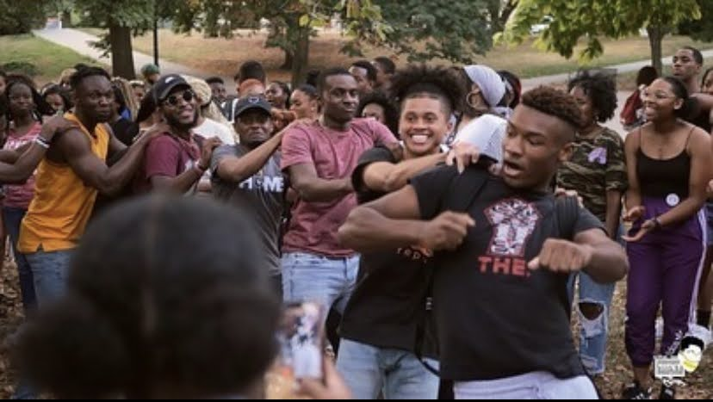

**MUNDO –** Multicultural Understanding through Non-traditional Discovery Opportunities

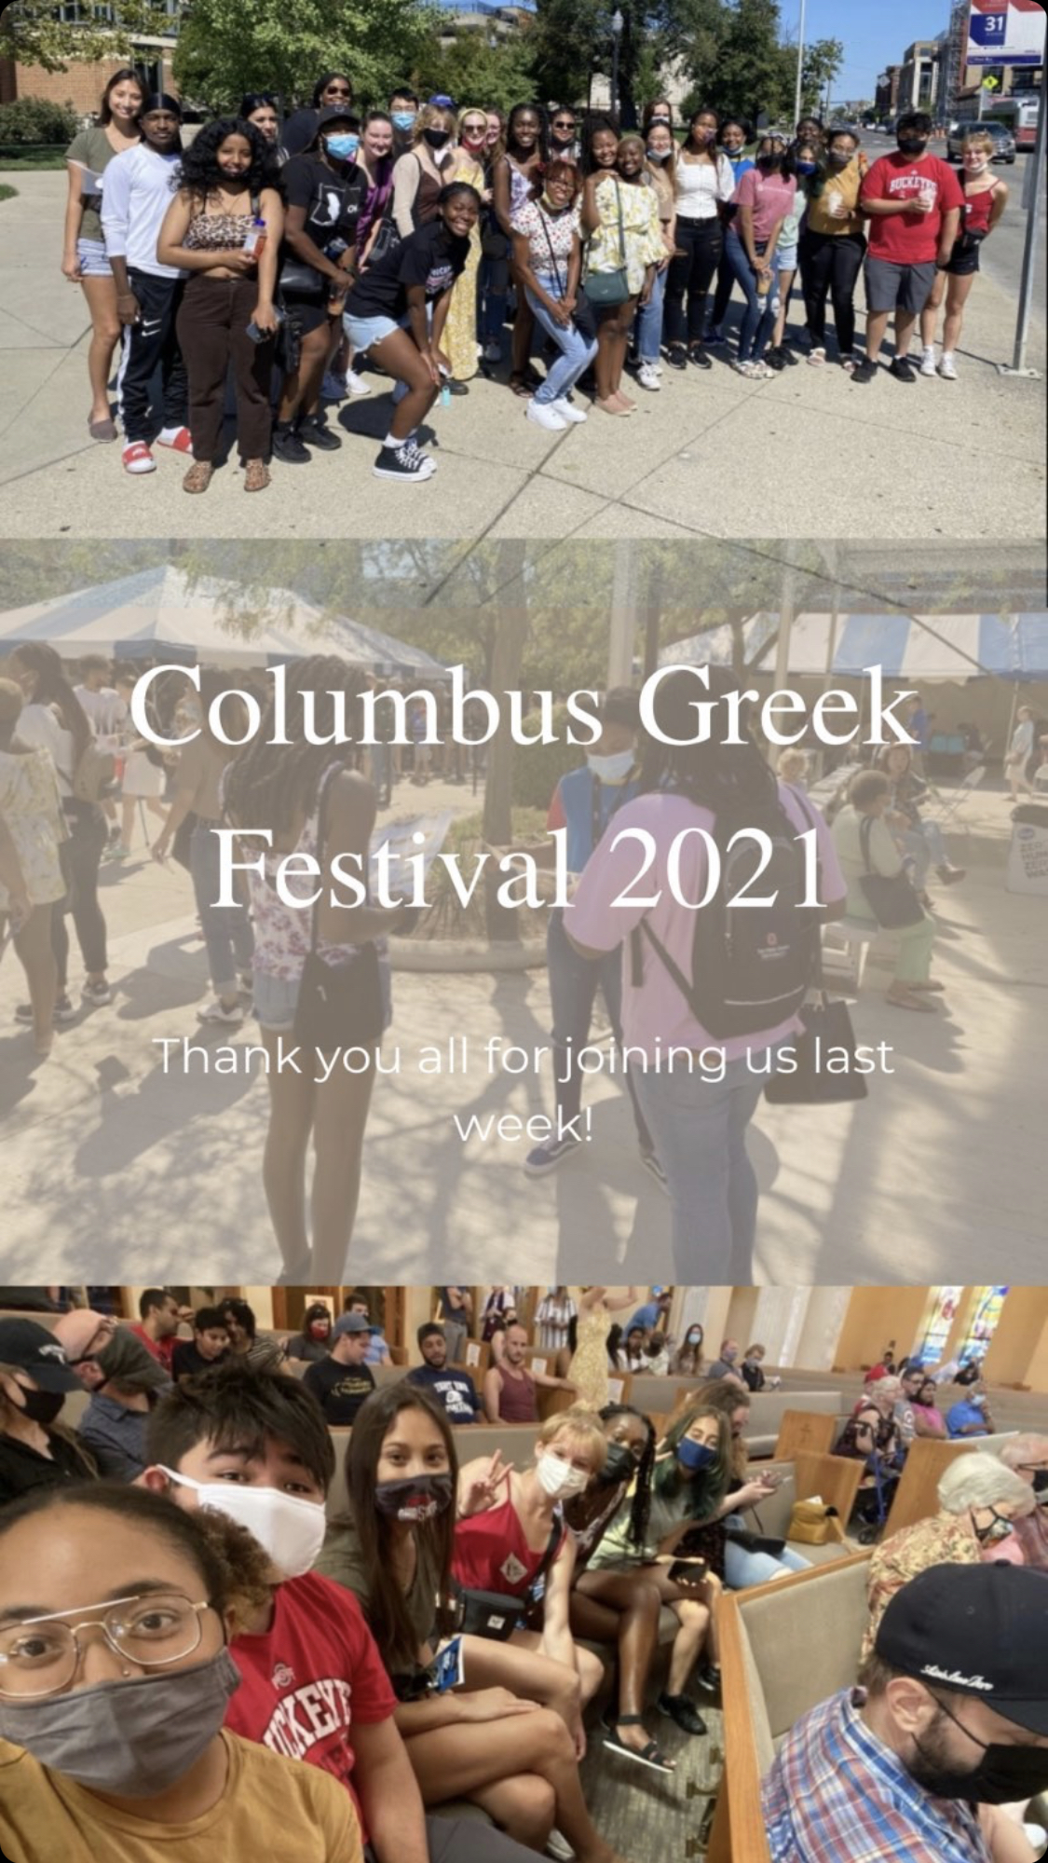

**What is MUNDO?**

MUNDO (pronounced MOON-DOUGH) at The Ohio State University is a Residence Life initiative and student organization for students who want to learn about and become involved with social change at the local, national, and global level using service, learning, and leadership.

**What is MUNDO short for?**

MUNDO stands for Multicultural Understanding through Nontraditional Discovery Opportunities. MUNDO also means “world” in Spanish, which ties in with our goal of promoting global citizenship.

**What are the three pillars of MUNDO?**

Service, learning, and leadership.

**What does MUNDO do?**

MUNDO provides participants with opportunities to connect through **service** by facilitating respectful, brave spaces that promote advocacy and informed citizenship via exploration and engagement with a diverse array of ideas and perspectives.

* Volunteering with STAR HOUSE, a resource center for homeless youths

MUNDO offers participants opportunities to **learn** how to gain a better understanding of themselves, the world around them, and their connection with others.

* Weekly Mondays with MUNDO meetings which are workshops and events focused on topics related to cross-cultural learning, anti-racism, and social change.

MUNDO also gives participants a chance to **lead** in ways that prepare them to be a catalyst for justice.

* ACTION TEAMS – student planning teams who create weekly experiences for the group

**How do you join or become active with MUNDO?**

Mondays with MUNDO meetings are held at 6:30 pm in the Ohio Union or virtually every week. MUNDO also holds fall, winter, and spring break trips.

**MUNDO 2021 Teaser video:**

<https://www.dropbox.com/s/p1jbxlvwhthkwsy/MUNDO%20Teaser%202021.mp4?dl=0>

**Want to learn more about MUNDO?**

* **The MUNDO website:** <http://involvedliving.osu.edu/mundo/>
* **Facebook:** <https://www.facebook.com/osumundo>
* **GroupMe:** <https://web.groupme.com/join_group/33822708/rODLHP>
* **Instagram:**  <https://www.instagram.com/osu_mundo/>
* **Twitter:** @MUNDOOSU1

**NRHH –** National Residence Hall Honorary



**NATIONAL RESIDENCE HALL HONORARY (NRHH)**

We are comprised of the top 1% of leaders on campus and participate in activities surrounding recognition, service, and leadership. We are the perfect organization for those that are looking to get more involved in residence life and want to develop their leadership skills and experience!

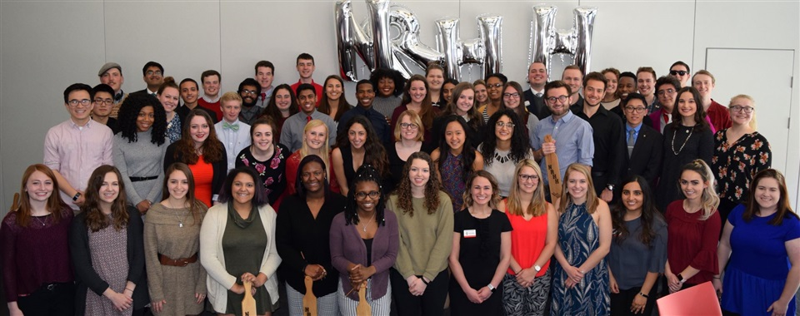

**Why YOU should apply:**

1. We are the only honorary focused on on-campus living. This means we want to make an impact where YOU Live!
2. But we also care what happens outside of Ohio State! We work hard to extend our service projects outside of campus and into the greater Columbus-area, and BEYOND!
3. Like how we take a Buck-I-Serv trip to Florida! (And all NRHH members got 50% off!!)
4. We are also all about RECOGNITION! Everyone likes being recognized for the awesome things they do, and that's where we come in! We administer Ohio State's OTM program, BUT –
5. -- Also do other recognition activities, like delivering gifts to all residence life staff. Recognition builds positivity and makes builds an awesome campus!!
6. We also work with other campus organizations like RHAC (and all ILOs!) and Undergraduate Student Government on unique projects that serve the on-campus population!

**Induction of new members occurs once a semester! Be sure to check out** [**www.involvedliving.osu.edu/nrhh**](http://www.involvedliving.osu.edu/nrhh) **for updated information on application deadlines.**

Follow us on Instagram @buckeyenrhh

**OTL –** Off The Lake Productions

**What is OTL?**

Off the Lake Productions is The Ohio State University’s only student run, service-based theatre organization on campus. Off the Lake offers service and community opportunities for members as well as produces four mainstage productions each year. Along with our mainstage productions, OTL also has our Peer Theatre program in which we write and perform skits dealing with topics and situations in which college students may find themselves.

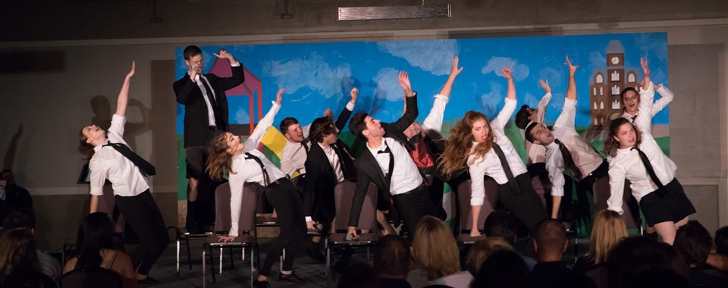**Mainstage Productions 2021-22**

* Fall Cabaret
* Night of One Acts
* The Great Gatsby
* Heathers the Musical

**How to get involved with Off the Lake?**

**Students interested in joining:**

* Audition for the play or musical or apply for crew in October! Can’t wait until October? Join the general body by contacting [offthelakeproductions@gmail.com](mailto:offthelakeproductions@gmail.com) or attending an info night in early September.

**RAs and other Res Life Staff:**

* Contact [offthelakeproductions@gmail.com](mailto:offthelakeproductions@gmail.com) to request Peer Theatre perform a skit and facilitate a dialogue for your next event!

**Want to learn more about OTL and stay in the loop?**

* **The Off the Lake website:** <http://involvedliving.osu.edu/otl/>
* **Instagram:** @offthelakeosu
* **Twitter:** @OfftheLakeOSU
* **YouTube:** Off the Lake Productions

**CARE –** Cultural Ambassadors for Resident Enrichment

### http://involvedliving.osu.edu/posts/images/img-9625-big.jpgWho are we?

CARE is a student-lead organization that seeks to create space where diverse students come together to cultivate intercultural competencies while preparing students for life after college and the globalized world.

We are a student-led organization affiliated under Office of Residence Life and are composed of a group of proactive leaders who are actively involved in various Residence Halls. We CARE about the social and cultural adjustment processes of incoming international students, especially of how they interact with domestic students in Residence Halls and strive to build a welcoming and strong community among both international and domestic students that promotes well-being and success through a variety of social, academic and educational support programs.

### Who can join CARE?

CARE is open to all undergraduate students at The Ohio State University! Past members have come from all over the world, from Columbus natives to international students from China and Morocco!

### What can CARE members expect?

CARE members can expect once-a-month General Assembly meetings where they learn about OSU resources, student organizations, and are assisted in polishing employable skills, such as interview skills and resume editing.

Once-a-month newsletters detailing upcoming events and member highlights on the CARE website are also an important part of CARE.

### What types of events does CARE host?

We host a wide variety of events, from International Desert Night to Karaoke with CARE. All of our events focus on learning about foreign cultures and international affairs, but CARE members put their own spin on this criteria.

### How much does it cost to be a CARE member?

Being a CARE member is FREE! Our organization is supported by The Ohio State University’s Office of Residence Life, which gives us the freedom to give CARE members amazing opportunities and put on fun events without asking for a fee.

**Benefits**

* Enrichment of global perspectives and connections throughout the world
* Enhancement of a powerful employable skill set for future professional opportunities, including interview skills, resume building, career advising, leadership development, cross-cultural communication, event planning, financial skills, etc.
* Membership in a lasting network with an inspiring cohort of global leaders
* Influence on Ohio State’s course of globalization
* Certificate of participation as a token of appreciation in recognition of contribution

### 

### How can I keep in touch with CARE?

CARE has an instagram page where we post about upcoming CARE events as well as events hosted by other Office of Residence Life organizations. Check us out! @care.osu

You can also email us at [care@osu.edu!](mailto:care@osu.edu!)