eRezLife Tutorial

What is eRezLife?
eRezLife is an online program management platform utilized by Residence Life to track the development of programs from start to finish.

To login into eRezLife, visit: https://osu.erezlife.com/one.php
Upon using this link, you will be directed to log in with your dot number and password.

When you log in, you will be brought to the eRezLife inbox page. On the left side of the inbox are tabs: People, Bulletins & resources, Forms, Reports, Communication, and Settings (if applicable).

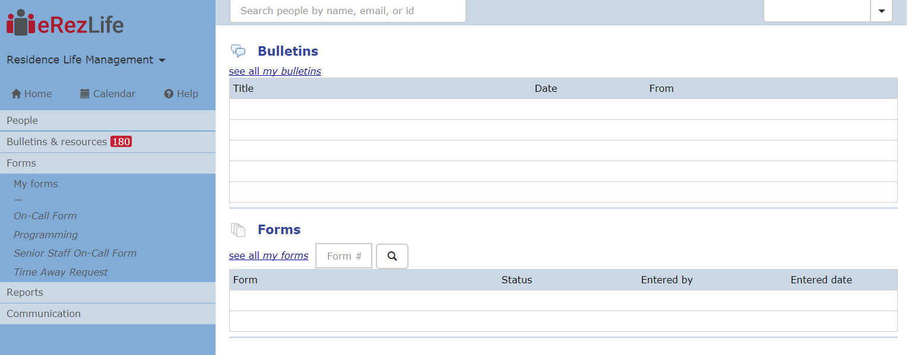

The Forms tab will be the most highly used area of this program for both Professional Staff and Paraprofessional Staff Members.

Inbox Note: The inbox is where you will see any programs that have been “sent” to you. All programs fall into either the categories of watching or closed. Watching is where you can see all programs that are sitting in the que of the program organizer. That means that a senior staff member has reviewed the program request and has sent the request back to the organizer for further action. Closed is where you can see all programs you have closed. Closing a request is an action typically reserved for when no further action for a program request needs to take place. You have the option to expand or condense in order to see more or less information for each program.

Create & Submit new Program Requests

Select Programming from the Forms tab. When you initially click on the Forms tab on the left side, you will see additional tabs labeled My Forms and Programming. My Forms will highlight past programs that you have submitted. Programming will be the function that allows you to create and submit new program proposals.

Complete all relevant data entries. All items marked with an * asterisked are required. The system will not permit you to submit a request without these fields completed.

General Information Data Entry: In this section, provide information regarding the date and time of the program. Also select the Residence Hall affiliated with the organizer’s residence hall. For instance, if the Bradley/Paterson Community Council were organizing a program, “Bradley/Paterson Halls” would be the Residence Hall selected for this section even if the program is not actually taking place within the physical location of Bradley/Paterson Halls.

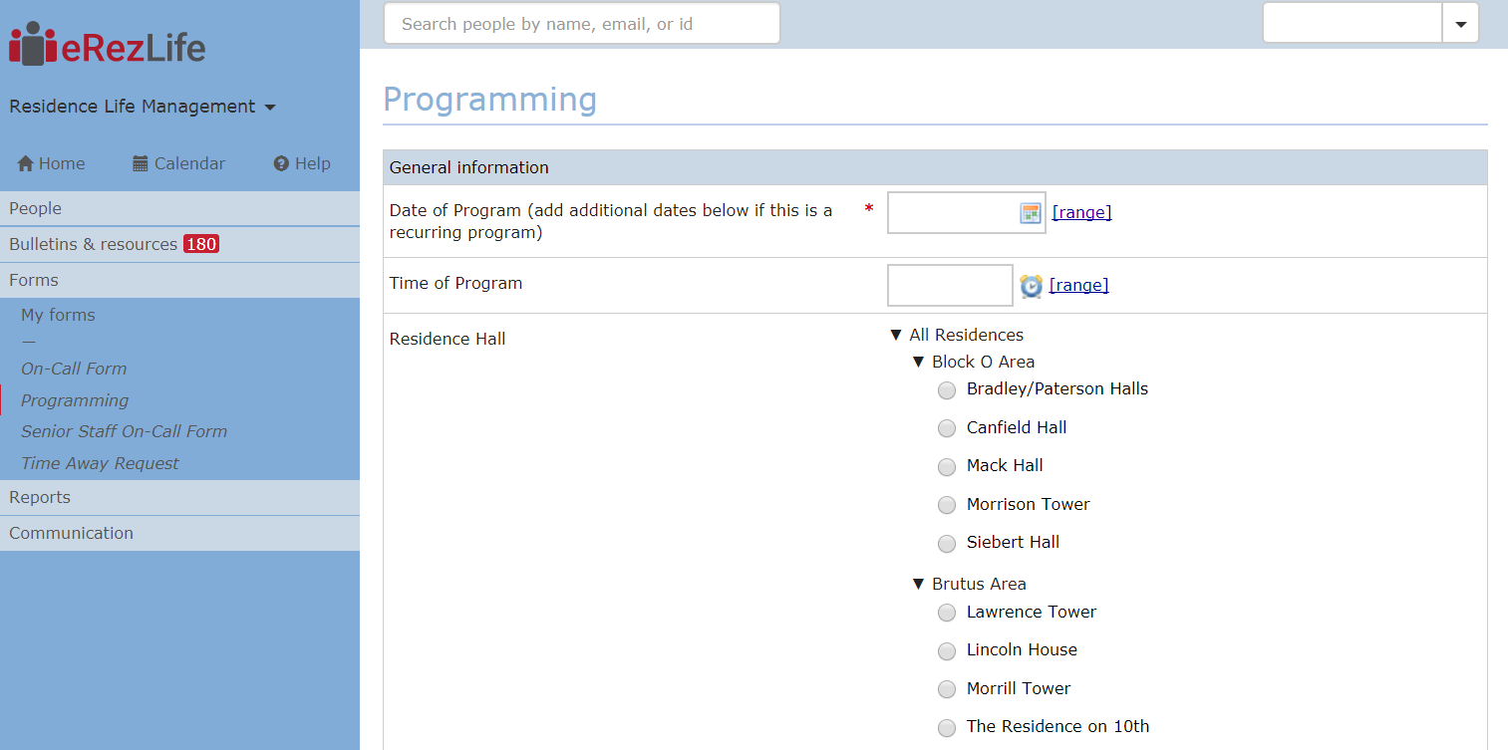

Staff Member Information: This is where the organizer’s information can be submitted. This section is not limited to just Staff Members. It can be used by any eRezLife user. The organizer’s information should be reflected in the Name/Staff Type/Role areas. In the Supervisor/Advisor Name, select the name of the professional staff member that supervises or advises the organizer. (If you are a senior staff member organizing the event, simply select yourself in the section.) Professional staff members are listed in a drop down box. Start typing the last name and it will easily pull up the name.

NOTE: If there are multiple staff members running the program, click on the green plus sign icon to create additional boxes to log in their information.

Pre-Event Program Proposal Details: This is where the title, details, location and marketing of the program will be shared. Key items for paraprofessional staff to be detailed in filling out are the description of the program, marketing plan, budget and learning outcomes and content areas of the program.
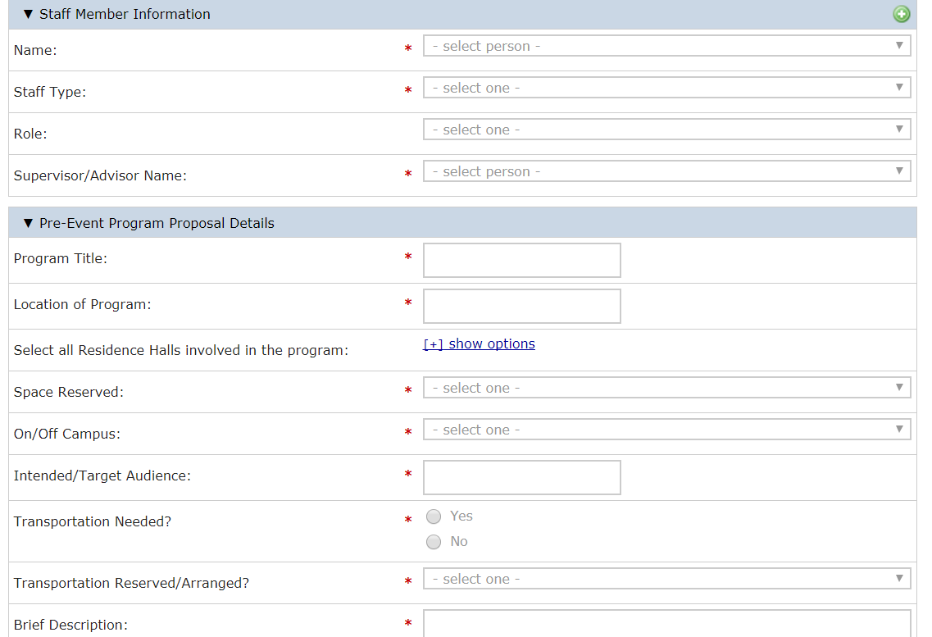
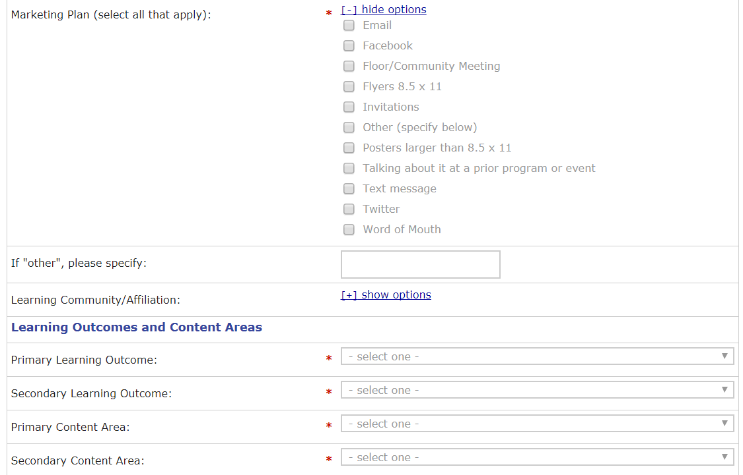

In the Funding section, organizers will need to be as detailed as possible. Include the items you are purchasing and the estimated cost for each. Organizers can also preference method of payment. Options include the Huntington Pay Card, reimbursement, nothing (for programs that will not have a cost to host) or Senior Staff help (an option for students if they need senior staff assistance to purchase goods by way of check, contract, or large purchases).

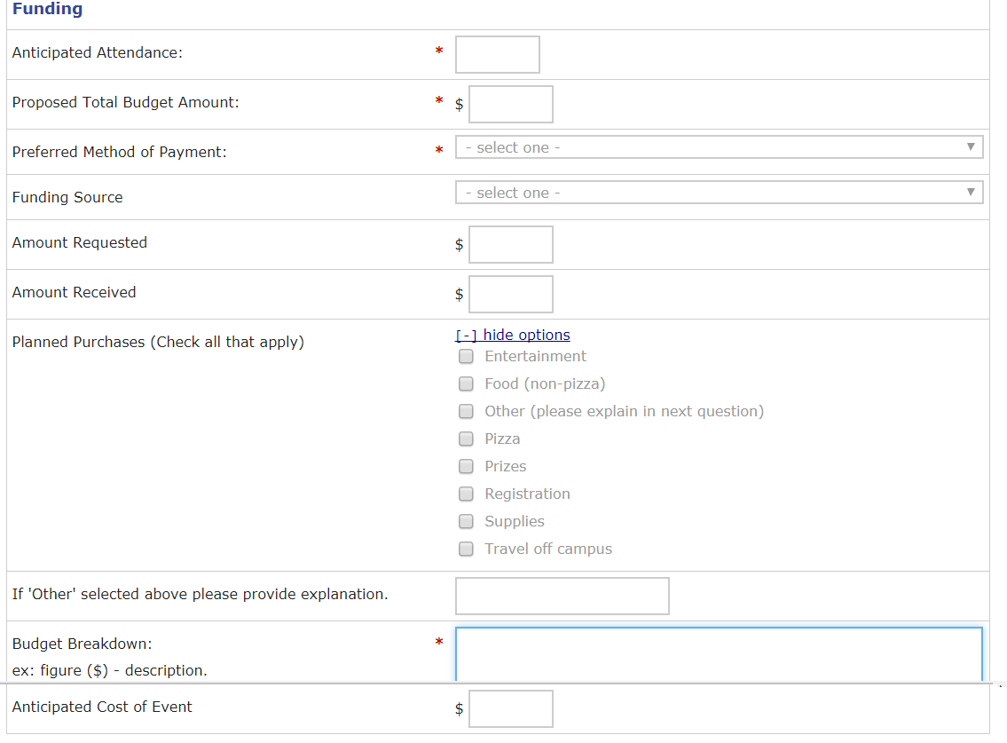

Presenter Information: If an outside faculty/staff member is part of a program, their information can be shared here.

Attachments: Upload advertisements/approvals/email correspondences here.

The Attention Section instructs the user who is entering the program details that they need to scroll down and submit the form to the appropriate individual (HD, AHD, or Community Council).

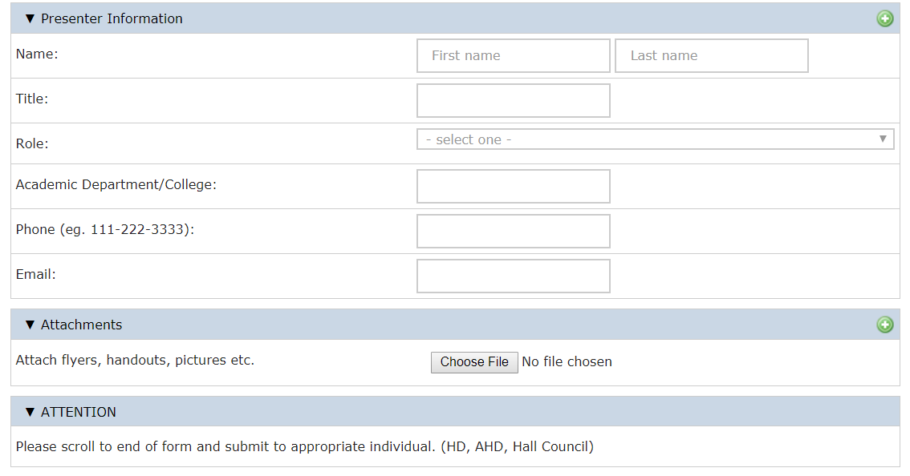

AT THIS POINT, THE PROGRAM PROPOSAL IS READY TO BE SUBMITTED.

Note: The remainder of the form should be completed after the event.

Next Steps: Selecting HD Review or AHD Review will direct the user to a new screen. On that screen, the user should select the professional staff supervisor or advisor. (If Community Council Review is not an option and this program needs to be reviewed to the Community Council for the next step, the professional staff member will route it to the Community Council). The user can choose more than one person to review the program proposal.

Behind the Scenes: The senior staff reviewer(s) will then receive a message that they have a program to review.
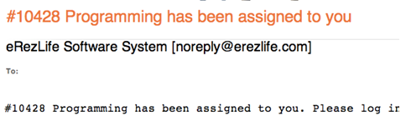

Note: If the program was sent to more than one person, both parties will get the same email and it will appear on both screens. The first person to click on programming will get a screen that will have the details listed.

Once Senior Staff enters the Programming page, they can review the information that was entered and provide any comments in the Senior Staff Pre-Event Comments/Feedback section. Here Senior Staff supervisor will provide you with an Approved, Approved with Reservations or Not Approved status for program submissions. In the Pre-Event Proposal Feedback box, Senior Staff will type comments to for the program and the rationale for the status. This is where organizers will need to go back to fix something, speak with their Senior Staff supervisor or advisor, or be given the notification that the organizers can proceed forward with implementing the program. This is also a good way for organizers to know if they are approved for the Huntington Pay Card and need to arrange a time to pick it up.

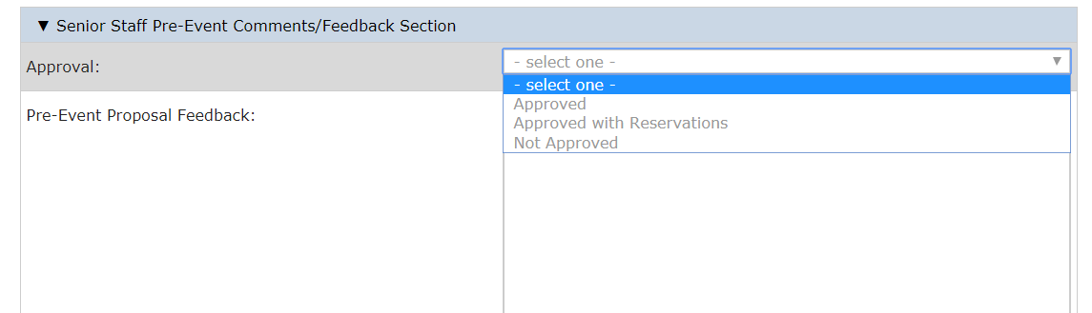

Upon entering the Approval Status and giving Feedback, the approving party will scroll to the bottom of the page, and click the “Send to Previous User” button. This will put the program proposal back in the hands of the organizer planning the event. The organizer will get a similar email that the approver did letting them know that the program has been passed back to them.

Upon completion of an approved event, the user/organizer who hosted the program will go back to the Program form and enter in the Post-Event Assessment and Reimbursement section. For List of Expenditures, the organizer will want to list out each item bought and the actual cost in a detailed, itemized list.

In this area, there is also a prompt for the organizer to consider filling out an “Of The Month” nomination for the program, along with the link to the OTM site.

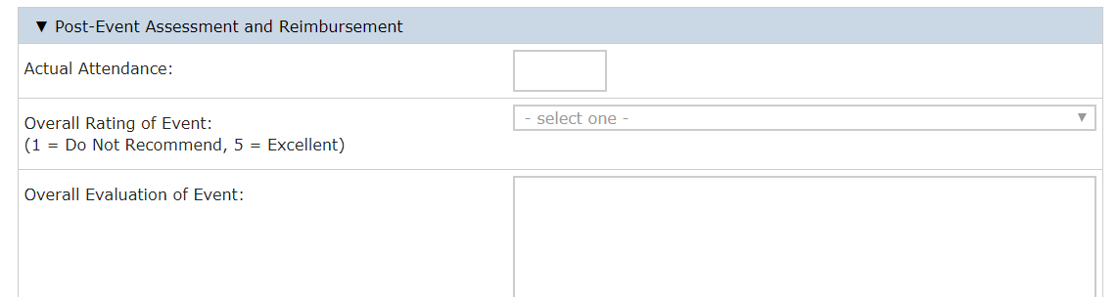
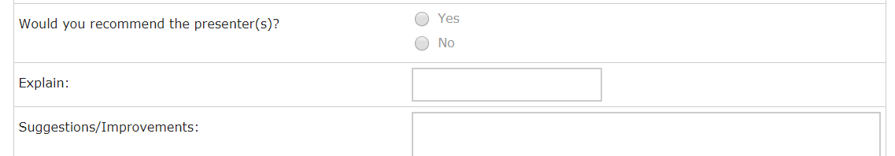

Reimbursement: The next section of the eRezLife program tracking system is meant to act as an electronic means of logging and tracking the receipts and checks associated with programming. This is where the name of the person or organization being paid should be listed.

NOTE: Click on the green plus sign to add additional names for reimbursement.

Receipts: Organizers should upload pictures they have taken of receipts, or scan them in, to have a digital copy of the expenditures saved.

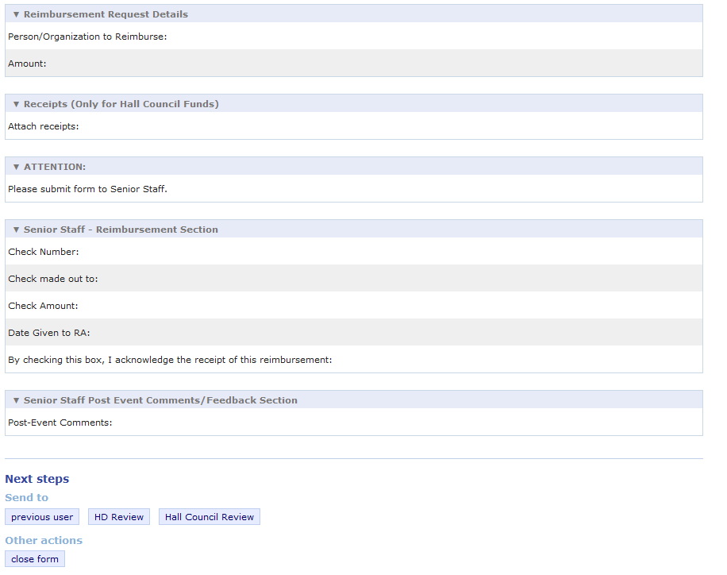
Upon posting reimbursement details, and attaching receipts, the organizer will come across another Attention Section that tells them to send the form back to their supervising or advising Senior Staff member. The Senior Staff member will get another email letting them know the program has been sent back to them.

Once a program is completed, Senior Staff will close the form and send any post-event comments to the programming paraprofessional staff member

