Intended Audience
This facilitation guide is designed for use by:
- Senior staff in paraprofessional staff meetings
- Hall Council advisors in executive board meetings
- ILO advisors in executive board meetings
- Student leaders as part of a hall program

Learning Outcomes
Through participation in this training session, students will be able to:
- Gain an enhanced understanding of self and others
- Develop strategies to enhance their own level of emotional intelligence
- Effectively manage interpersonal relationships and interactions with others

Sharing Content
- Presenter is encouraged to create a power point presentation to use with this guide.
- Participants should be told before-hand to bring an technology device, as they will be provided a link to an assessment test that will assist them in gauging their own emotional intelligence level. Presenter should also print copies of the scenario (see end of document).

Exercises and Activities
- Discussion: Defining emotional intelligence and describing its importance
- Activity: Emotional Intelligence Self-Assessment
- Activity: Application through scenarios

Assessment & Follow-Up
To be determined by the Department of Residence Life

Facilitation Guide

Section 1: Definition and Importance (Time: 10 Minutes)

Begin by asking participants: What comes to mind when you think of emotional intelligence? (Considering using “think, pair, share” if group is quiet).

Give them the general definition: Emotional Intelligence is the ability to be aware of, express, and manage one’s own emotions as well as the emotions of others in a positive way.

Ask for/provide examples of high and low emotional intelligence (see attached diagram)

Facilitate discussion on the importance of emotional intelligence.
As leaders and people in general, it is crucial to be able to effectively manage one’s emotions. Life will present very stressful situations at times, and we all must maintain ourselves even in the most challenging situations.
- High emotional intelligence means a more productive and cohesive environment when interacting or working with others. This also results in better decision-making and an overall better understanding of self and others.

- Here are a few other benefits:
  - Enhanced self-awareness
  - Enhanced physical health
  - Enhanced mental health
  - Improved interactions with others
  - Greater ability to withstand adversity

**Note to facilitator: These points should be elaborated on to allow students to better understand how a person may benefit in these ways. Feel free to add to the list.

Section 2: Emotional Intelligence Test (Time: 20 Minutes)

Introduce Emotional intelligence Test
- https://globalleadershipfoundation.com/geit/eitest.html
- This allows students to gain insight on how high or low they are in terms of their own self-awareness, self-management, social awareness, and relationship management.
- Remind students to not overthink the questions, but to simply answer them to the best of their ability and to move on to the next question.

After students finish, use the following questions to facilitate a 10 minute reflection conversation
- What are your reactions to you score? Do you agree with your score?
- How can you increase your scores in certain areas?
- Why is emotional intelligence important in your life?

**Note to facilitator: After students have time to answer the questions, allow a few to share and contribute to the conversation by validating them, offering encouragement, and sharing personal goals you may have toward increasing your emotional intelligence (if the space allows for it).

Section 3: Emotional Intelligence Scenario (Time: 20 minutes)

Introduce and pass out copies of the scenario. Give students five minutes to read through the scenario individually. After students have read through the scenario, divide students in to groups and give them 10 minutes to discuss the following questions.

- If you were in Alicia’s place, what would you have done when asked to go out?
- How would you evaluate Alicia’s emotional intelligence?
- How could Alicia have responded to her circumstances the next morning differently?
- What can Alicia do moving forward to ensure her emotions do not get the best of her again?

After 10 minutes, spend 5 minutes allowing groups to share out their responses to the small group.

Section 4: Ways to Increase Emotional Intelligence (Time: 5 minutes)

Conclude by offering these steps for increasing emotional intelligence.

- Reflect on your emotions: Take a second to think about the feelings you are experiencing, where they are coming from, and how to best manage them in the present moment.

- Ask others for perspective: Receiving feedback is a great way to track your progress.

- Be observant: How are you and others responding to the environment and situation around you?

- Use the pause: It is okay to take a pause and recollect yourself. This is a sign of growth and shows great self-awareness skills.

- Explore the “why”: Ask yourself “why” you are feeling a certain way. Is it due to things beyond your control? Can you reach out to others for assistance? Understanding the “why” behind the emotion helps to prepare you to respond in future situations.

- Ask “what can I learn from this?”: There is a lesson to be learned in every situation. Whether you responded negatively or positively, reflect on how you will move forward and ensure the best possible response next time.

- Practice and ask for feedback: Practice, practice, practice! You may not get it right every time, but a willingness to keep trying and seeking constructive feedback from others allows you to grow!

Resources:

How to Increase Your Emotional Intelligence: https://www.inc.com/justin-bariso/how-to-increase-your-emotional-intelligence.html

Improving Emotional Intelligence: https://www.helpguide.org/articles/mental-health/emotional-intelligence-eq.htm

Global Leadership Foundation: https://globalleadershipfoundation.com/geit/eitest.html
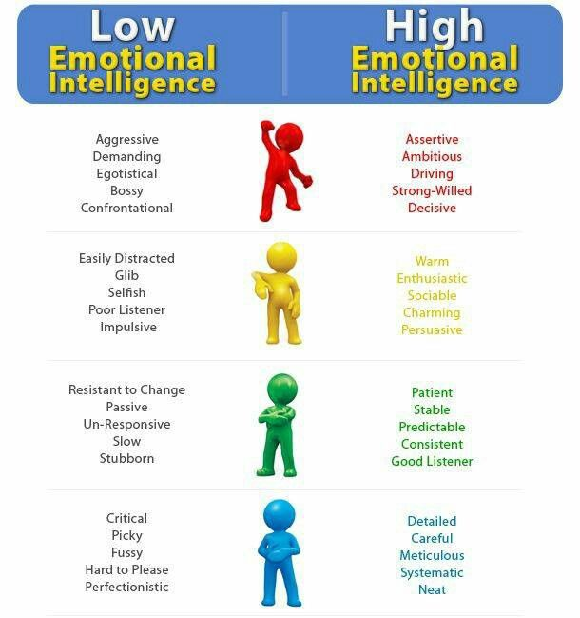
Red | Low Emotional Intelligence | High Emotional Intelligence
 | Aggressive, Demanding, Egotistical, Bossy, Confrontational | Assertive, Ambitious, Driving, Strong-Willed, Decisive
Yellow | Low Emotional Intelligence | High Emotional Intelligence
 | Easily Distracted, Glib, Selfish, Poor Listener, Impulsive | Warm, Enthusiastic, Sociable, Charming, Persuasive
Green | Low Emotional Intelligence | High Emotional Intelligence
 | Resistant to Change, Passive, Un-Responsive, Slow, Stubborn | Patient, Stable, Predictable, Consistent, Good Listener
Blue | Low Emotional Intelligence | High Emotional Intelligence
 | Critical, Picky, Fussy, Hard to Please, Perfectionist | Detailed, Careful, Meticulous, Systematic, Neat

Materials – Worksheet

It is Thursday afternoon and Alicia has a huge math exam at 8:00am the next morning. This is an important exam as it will determine if she will pass the class or not. She receives a text from her friend Michelle asking if she would like to hang out tonight for an hour or two. Alicia made it very clear to her friends and family that she would spend the night preparing for the exam. After Michelle insists that they will only be out for two hours at max and that it will be good for Alicia to get some fresh air, she convinces herself to go and promises that she will be back home by 10:00pm.

Alicia is out with Michelle and other friends and she is enjoying herself. Every time she looks at the clock, she notices it is getting later and later past 10:00pm. She reminds herself, just five more minutes, each time. Before long, it is 1:00am and Alicia’s exam is now only seven hours away. She is already exhausted and has no energy to study once she finally makes it home just after 2:00am. She contemplates pulling an all-nighter or getting a few hours of sleep before waking up to study.

After three hours of sleep, it is now 5:30am and it is hard to concentrate on her notes. Her roommate Jenna’s alarm starts to go off, but she keeps hitting snooze. Alicia complains “Don’t you see that I am trying to study? Either get up or go find someplace else to sleep!” Her mood is continuing to dwindle, and she receives a text from her mother telling her to have a good day and to call her after class. She snaps and replies, “Mom, I am not in the mood for this right now. I am trying to study and none of you will leave me alone!” Alicia feels like everything is about to explode. She is overwhelmingly tired, does not feel prepared for the test, and regrets her decision to go out with Michelle last night.

Reflection Questions
- If you were in Alicia’s place, what would you have done when asked to go out?
- How would you evaluate Alicia’s emotional intelligence?
- How could Alicia have responded to her circumstances the next morning differently?
- What can Alicia do moving forward to ensure her emotions do not get the best of her again?

